**Portfolio- Documentation: Creating a website By Anushka Thapa , 23085188**

Introduction

This documentation outlines the process of creating a website using HTML, CSS, and JavaScript. The website consists of six pages: Home, About Us, Service, Gallery, Prices, and Contacts. Each page serves a specific purpose and contributes to the overall functionality and design of the website.

**Project Overview:**

The goal of this project is to create a fully functional website that showcases various features and information about a fictional company. The website aims to provide users with an engaging and informative experience while highlighting the services offered by the company.

**Technologies Used:**

To create this website, HTML, CSS, and JavaScript were used. HTML was used for structuring the content of each web page, CSS was used to style the visual appearance of the website and lastly javascript which was used for adding dynamic elements to the website.

**Pages:**

In total there are six pages in this website which contains:

The Home Page- This page is the first page of the website. It is saved as index.html. This homepage is for a website called "Guitarn," specializing in guitar-related services. It features a navigation bar with links to different pages, including Home, About, Service, Gallery, Prices, and Contact. The main content area welcomes visitors with a prominent message introducing the website and highlighting its key offerings, such as guitar teaching and sales. Additionally, there's a login section where users can input their email and password to access member-exclusive features or services. Finally, at the bottom, there's a footer providing essential information about the company, including its contact details and copyright information. The homepage is designed to engage visitors and encourage them to explore the site further while also providing easy access to login functionality.

The output of this page is as shown below:

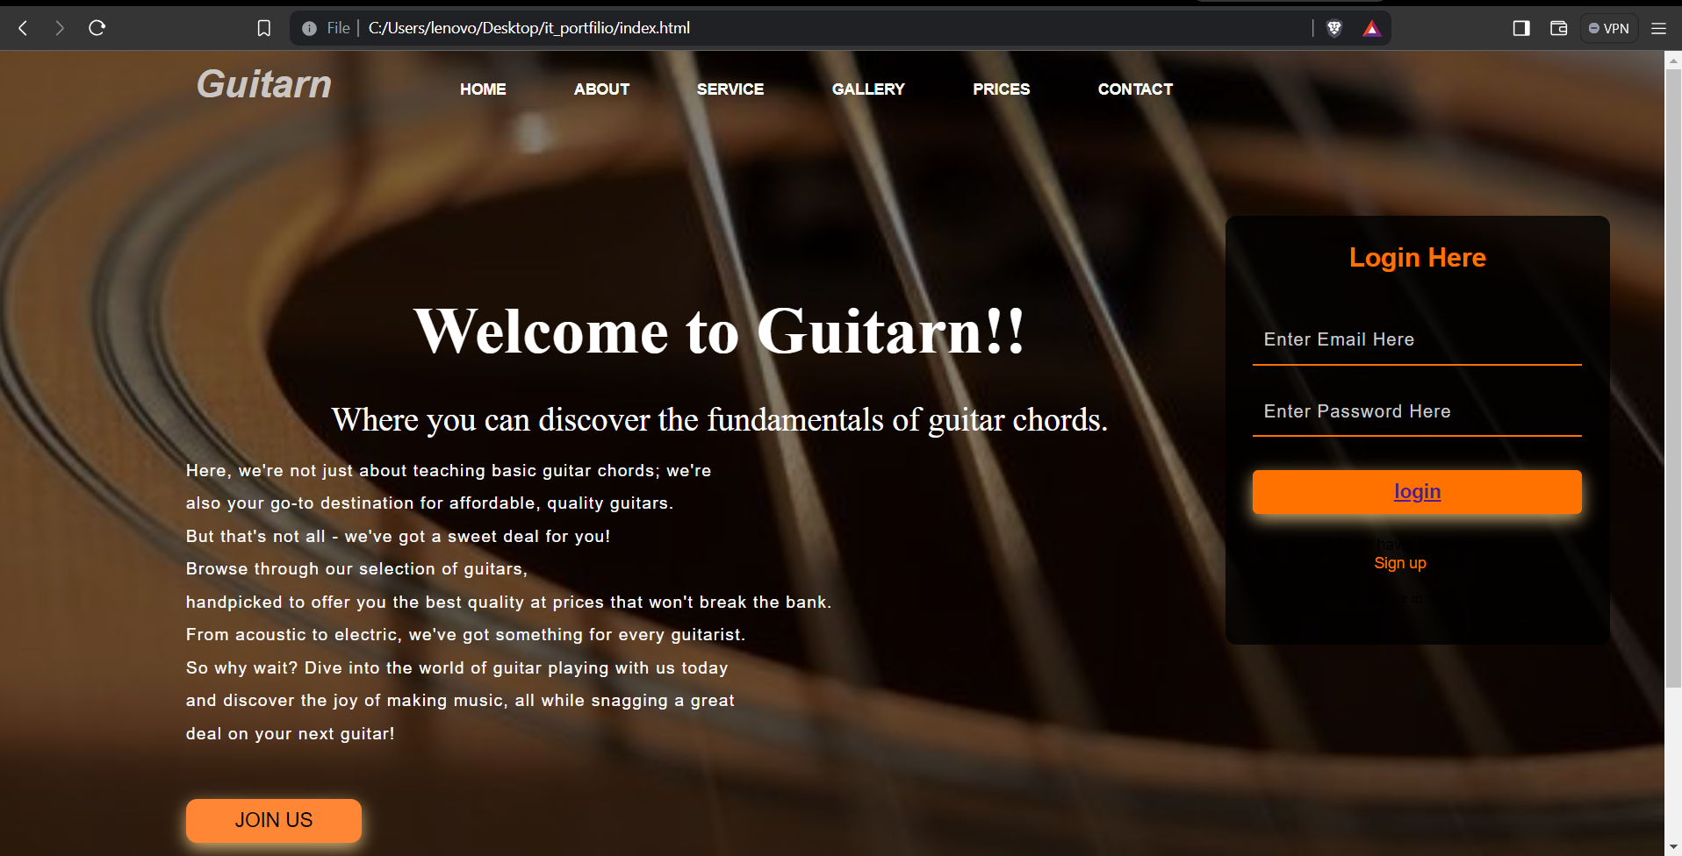

And the footer:



About Us Page- Like the home page this page also has a navigation bar. The main purpose of this page is to describe about the website’s mission.

The output for this page is:

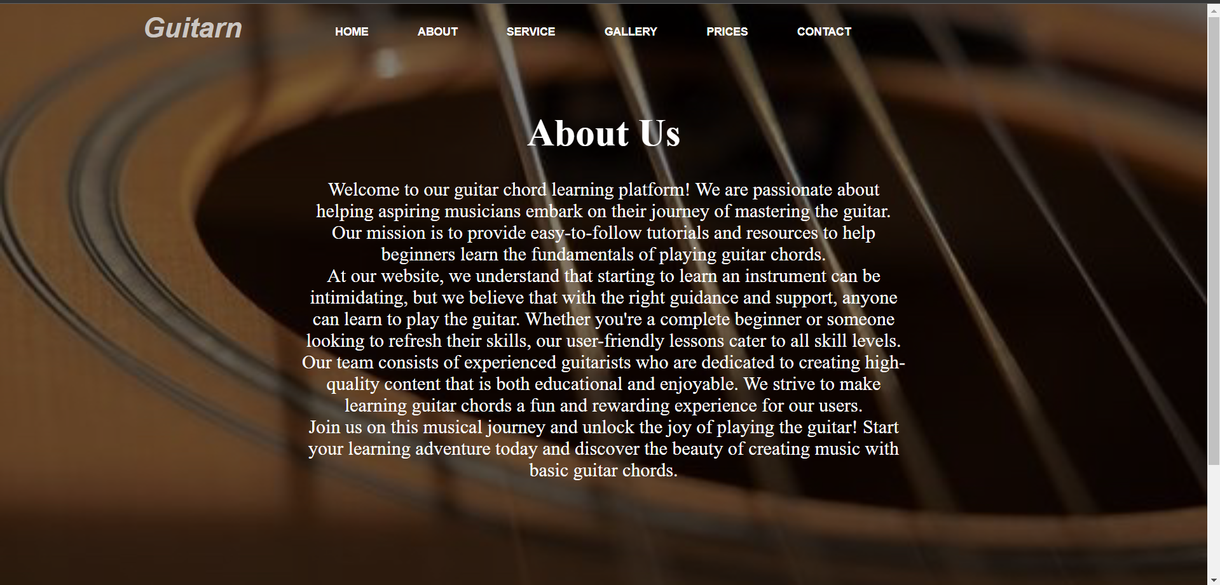

And the footer:



Service Page- This is the third page of this website. All the pages have a navigation bar which helps the users navigate around the website easily. The main content of the page is within a container div with the class "container3". It outlines four services offered by Guitarn:

Guitar Servicing: Professional maintenance services to keep guitars in top condition.

Guitar Repair: Skilled technicians available to fix any issues with guitars.

Guitar Restoration: Restoration services to revive vintage guitars to their former glory.

Guitar Retail: A selection of high-quality guitars available for purchase at competitive prices.

The output for this page is:

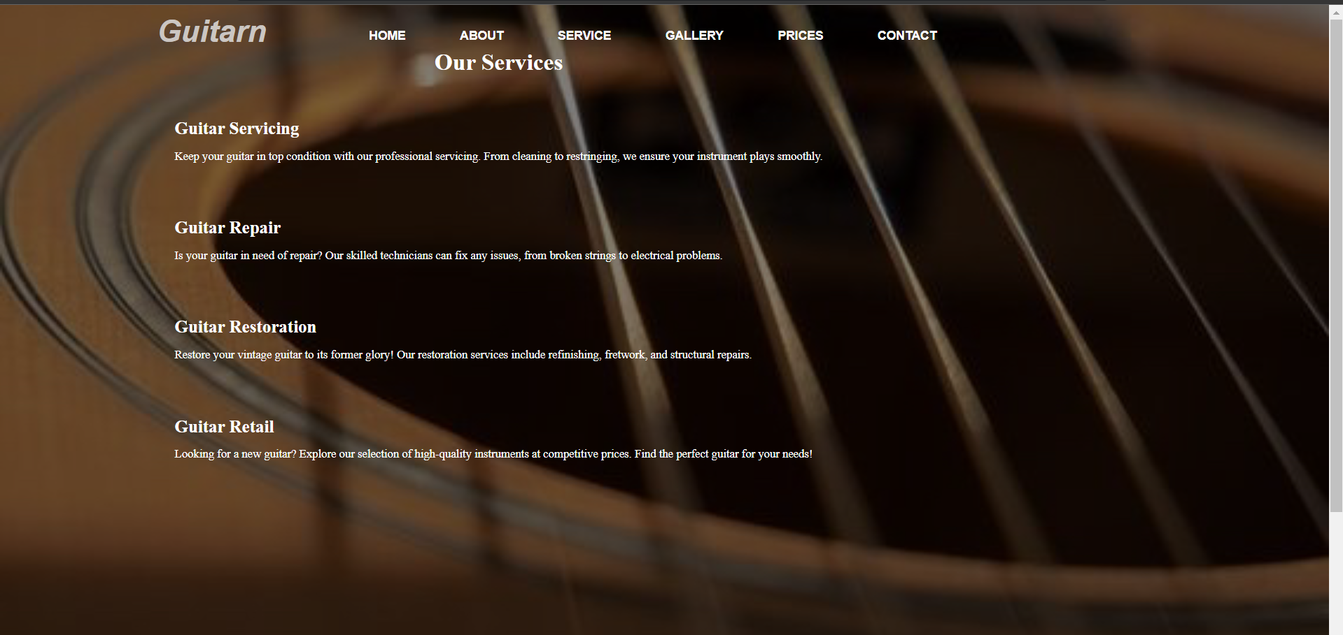

Lastly the footer:

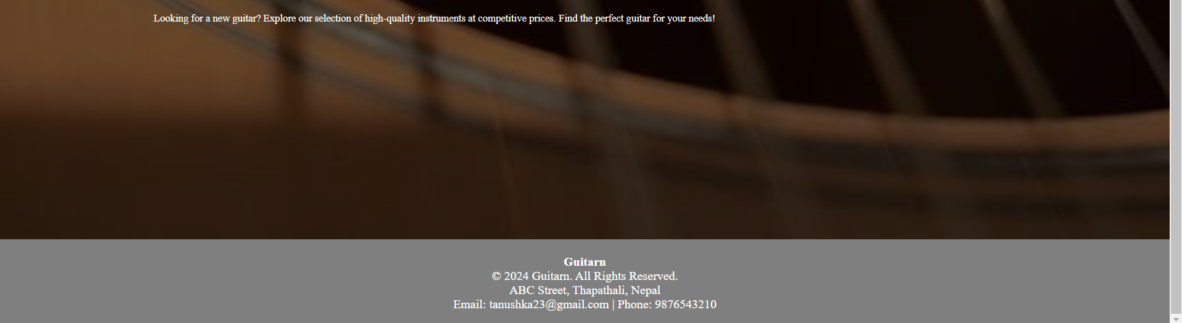

Gallery Page- The main content of the page is within a container div with the class "container2". It includes a slider that allows users to browse through images of guitars. The slider includes buttons to navigate to the previous and next images. The images are displayed in a loop, showcasing various guitars and guitar-related images.

The output for this page is:

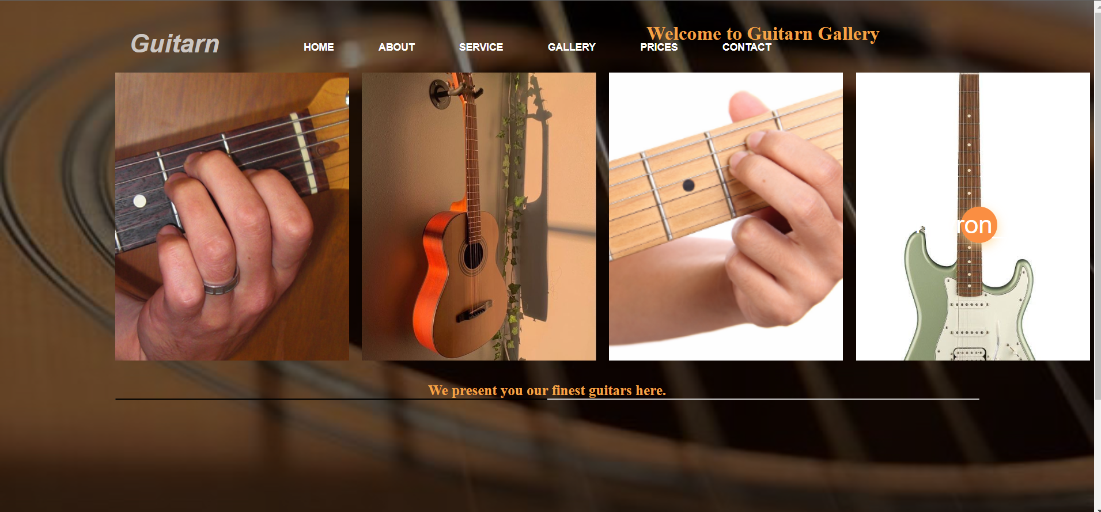

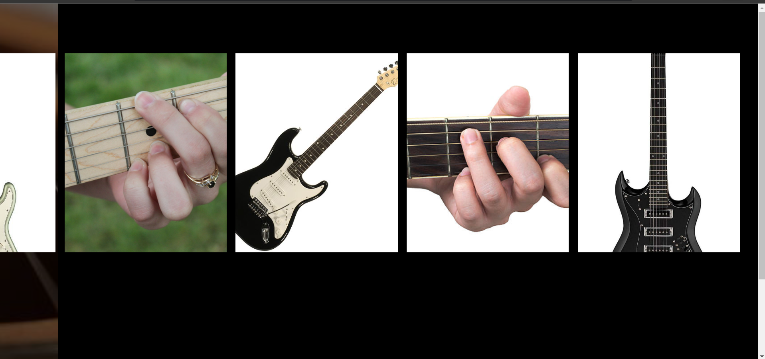

And the footer:



Prices Page- The main content of the page is the list of guitar prices, displayed in a structured format using HTML elements. Each guitar is represented by a div with the class "guitar", containing three child divs for the type, model, and price of the guitar.

Below the list of guitars, there is a footer section that contains essential information such as the website name, copyright details, and contact information.

The output for this page is:

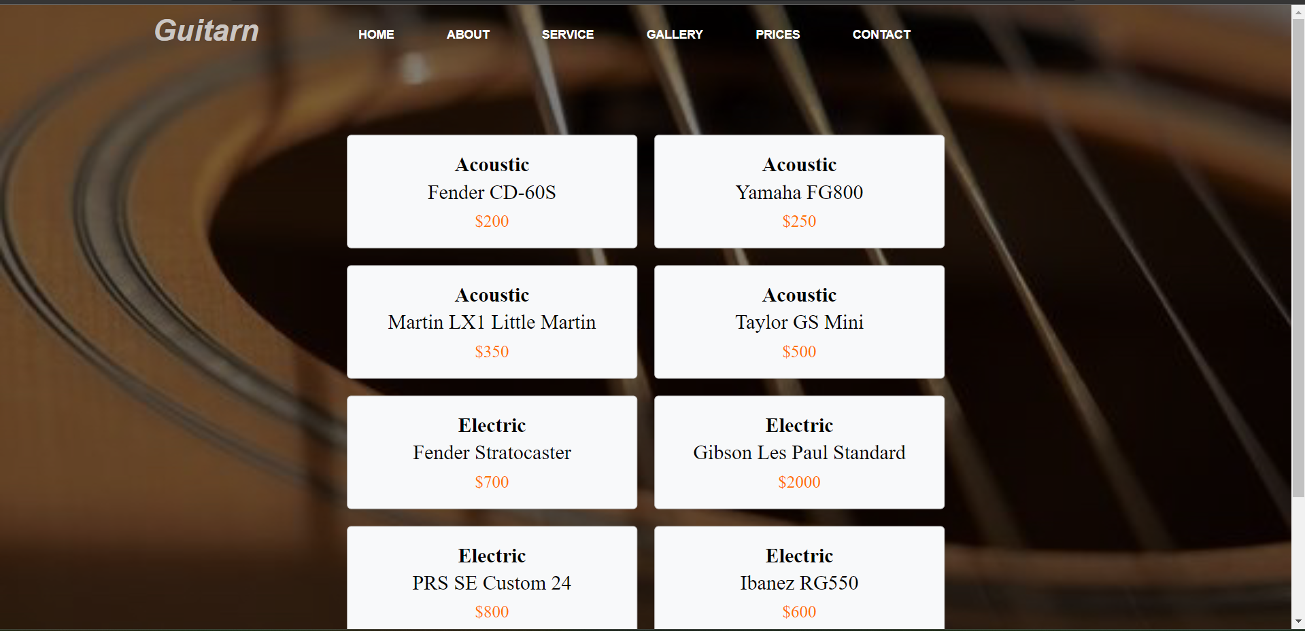



Contacts Page- The main content of the page is divided into two sections: "Connect with Us" and "Reach Us". In the "Connect with Us" section, users can fill out a form to send their requests. The form includes fields for name, phone number, email, subject, and message. In the "Reach Us" section, users can find contact information such as email, phone number, and address presented in a table format.

The output for this page is:

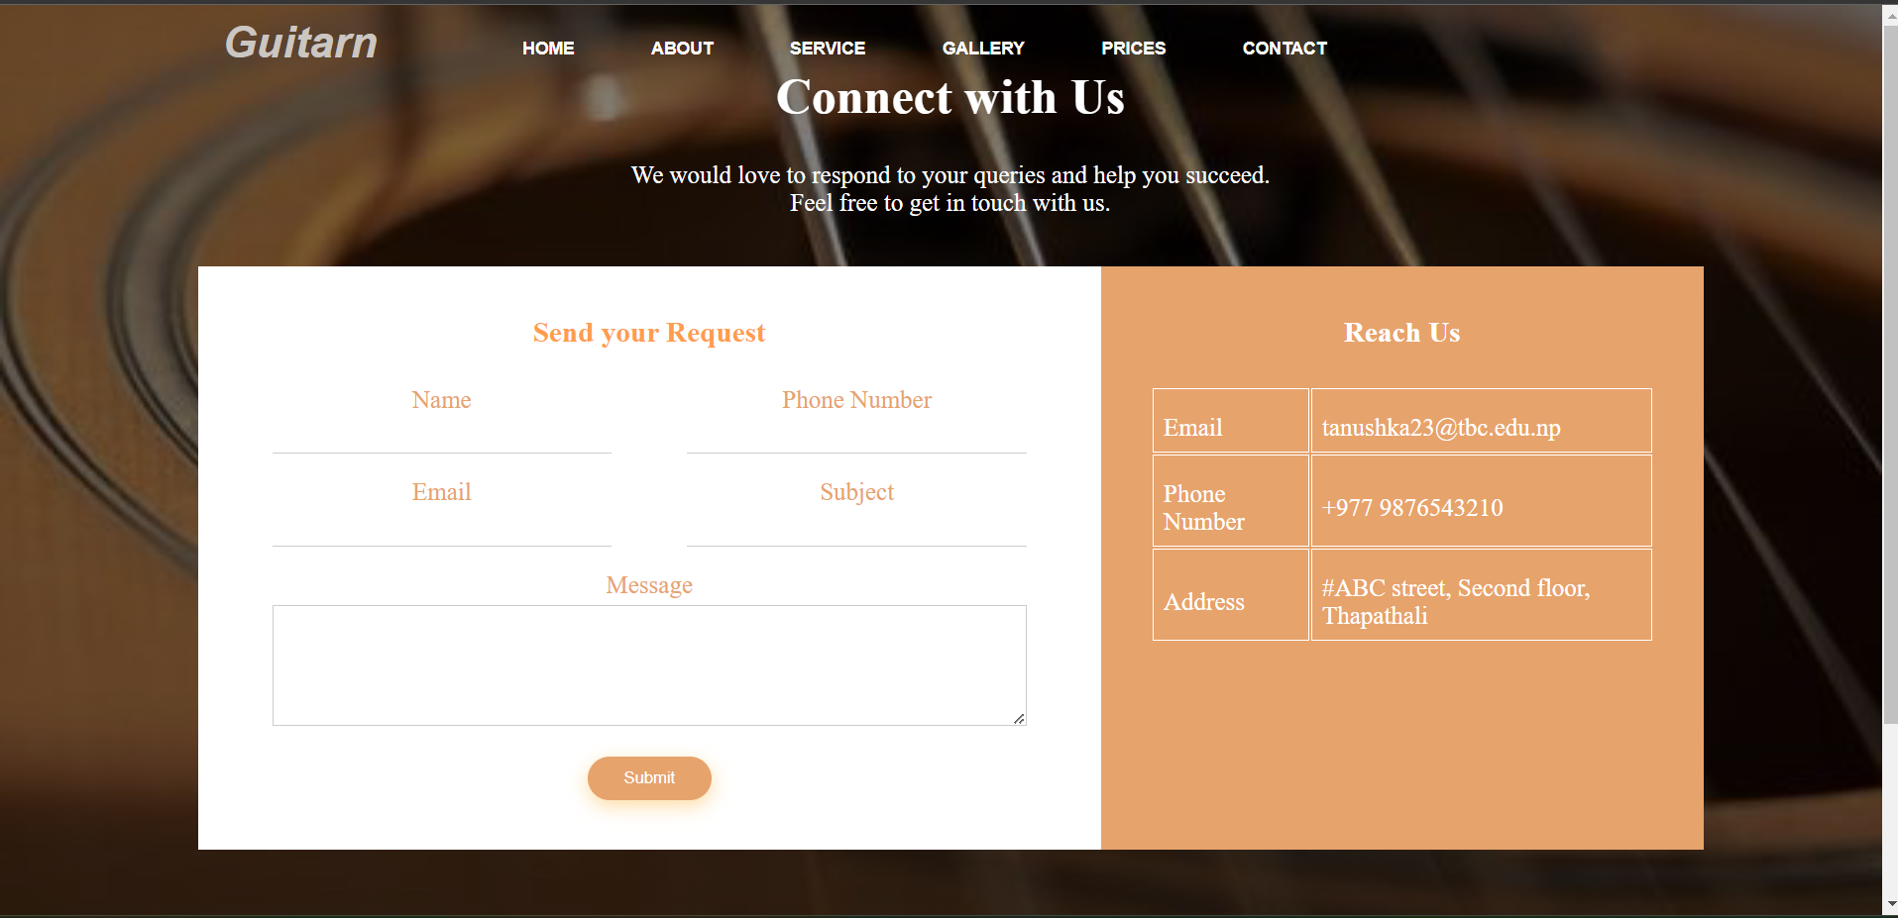



The mockup designs for the pages are:

Home page-

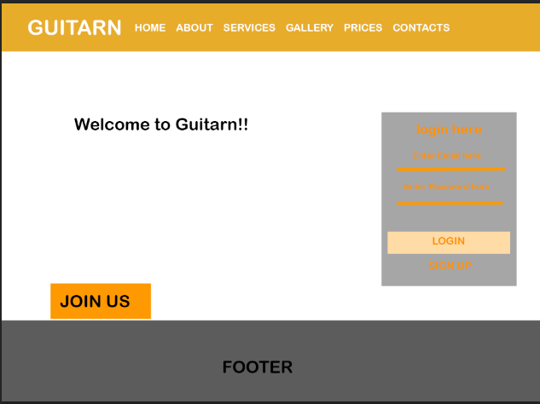

About Page-

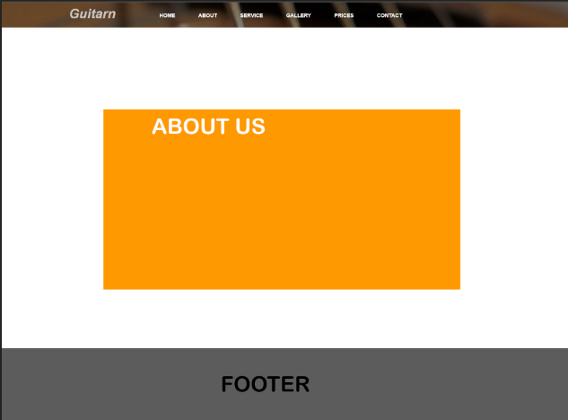

Service-

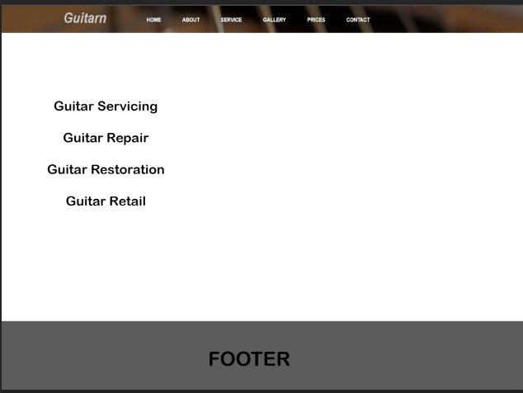

Gallery-

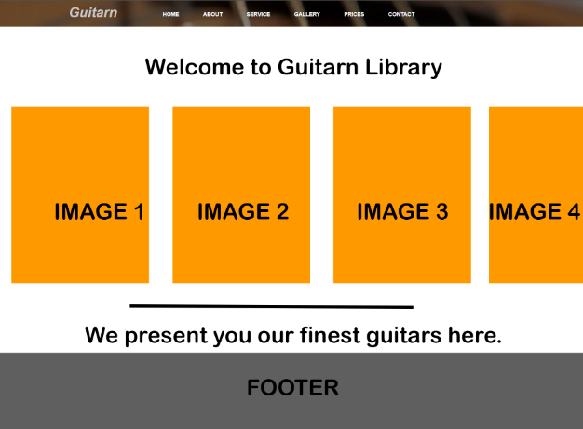

Prices-

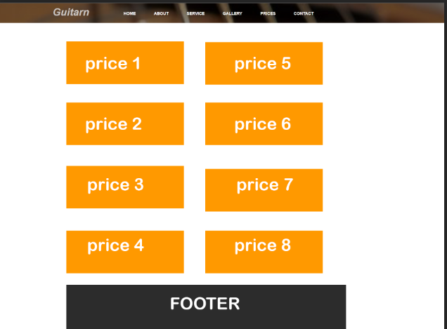

Contacts

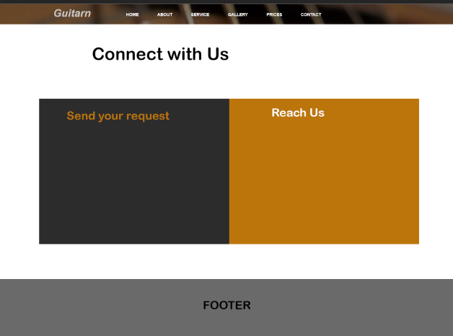

**Conclusion:** In conclusion, the Guitarn website offers a comprehensive platform for guitar enthusiasts, providing a range of services and resources to support their musical journey.